FE CSE-AIML ( A and B) AY 2025-26
Basic Electrical and Electronics Engineering BEEE ( ESC 102 )
Assignment 2
- Find the value of current flowing through the 30-ohm resistor. Using Thevenin’s theorem.
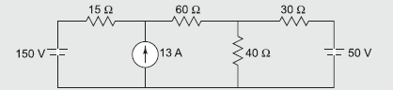
- . Find the value of current flowing through the 10 ohm resistor using Norton’s theorem
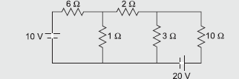
- Find the value of resistance R_{L} for maximum power transfer and calculate the maximum power.
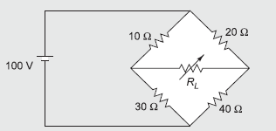
- Determine the value of R for maximum power transfer. Also find the magnitude of maximum power transferred
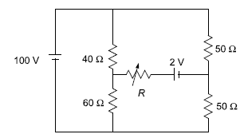
- Find current through 1ohm resistor using nodal analysis.
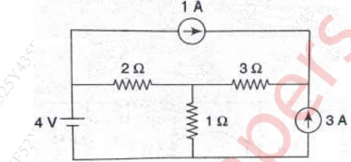

Course Teacher
Dr Nirmala K

